**SEQUENTIAL DIAGRAM**

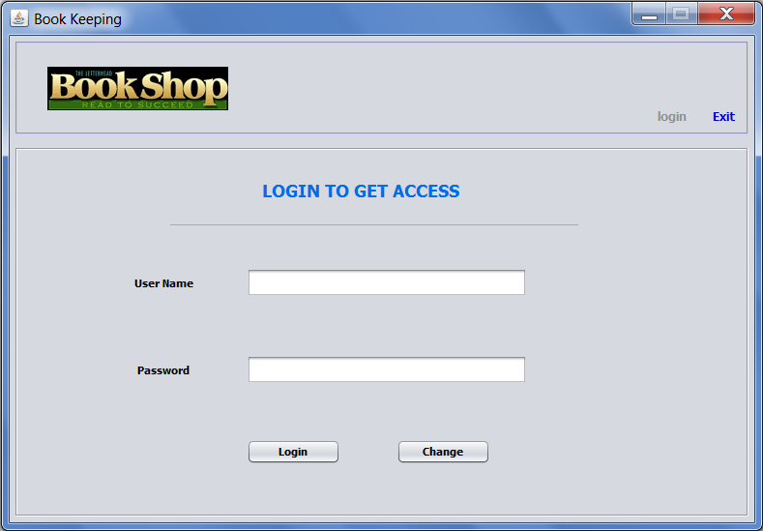

Login Window

In above login Interface, user will enter his *Username* and *Password*, and press **LOGIN** button for logging in…

if he authorizes successfully **Insert Window** will be opened:

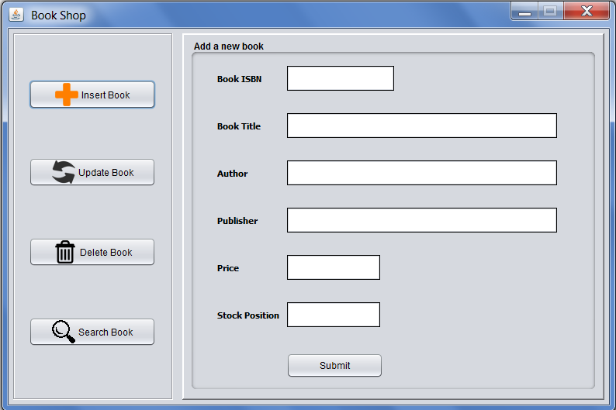

Insert Window

And if his authorization fails, ‘*Invalid Login Credentials’* error arises:

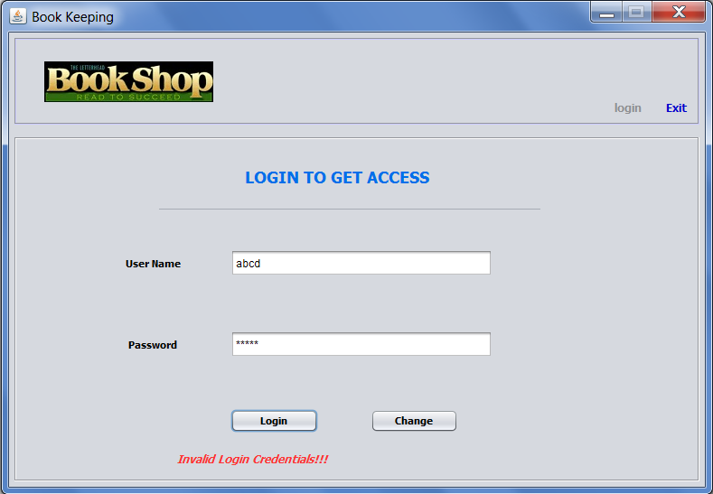

Error

On pressing **Change** button, if login credentials are valid, **Change Password** Window appears:

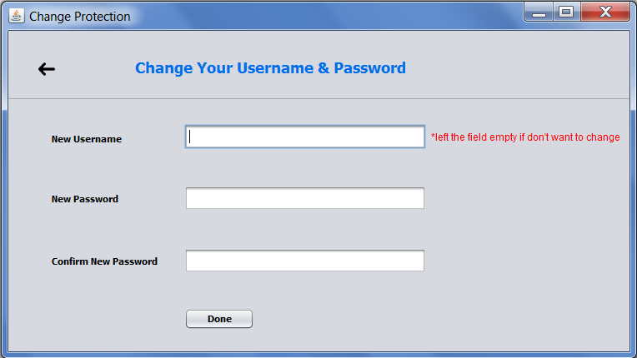

Change Password Window